|  |
| --- |
| College LaSalle |
| Project - Oriented Object Programming User and Technical Manual |
|  |
| Presented to: Mihai Maftei. |

|  |
| --- |
| Your name: Essam elfakharany  7/6/2022  Version 1.0 |

1. **Start by adding a short description of your project, and the languages (technologies) used:**
2. Language(s) A, B, C
3. tool Visual Studio version (2017 / 2019 / 2022)
4. **Present the print screens of yours forms, and have a detailed description of the functionalities (step by step).**

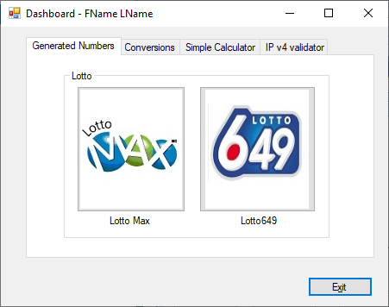

1. If you click on tab…
2. If you click on tab…
3. …
4. If you click on the Exit button, …
5. **Present the code of your application (forms).**

… your code goes here

1. **Present the classes and/or methods that you create or you did use in the project.**

|  |  |
| --- | --- |
| **Class/Method Name** | **Description** |
| 1. Class1 | Enter a short description of the class or of the method ………………. |
| 1. Class2 | Enter a short description of the class or of the method ……………….. |
| 1. double Method(int total) | Enter a short description of the class or of the method ……….. |
| 1. void Display() | Enter a short description of the class or of the method ………… |

1. **Present the difficulties that you have, what was the hardest and the easiest part of your project.**

… your presentation goes here …